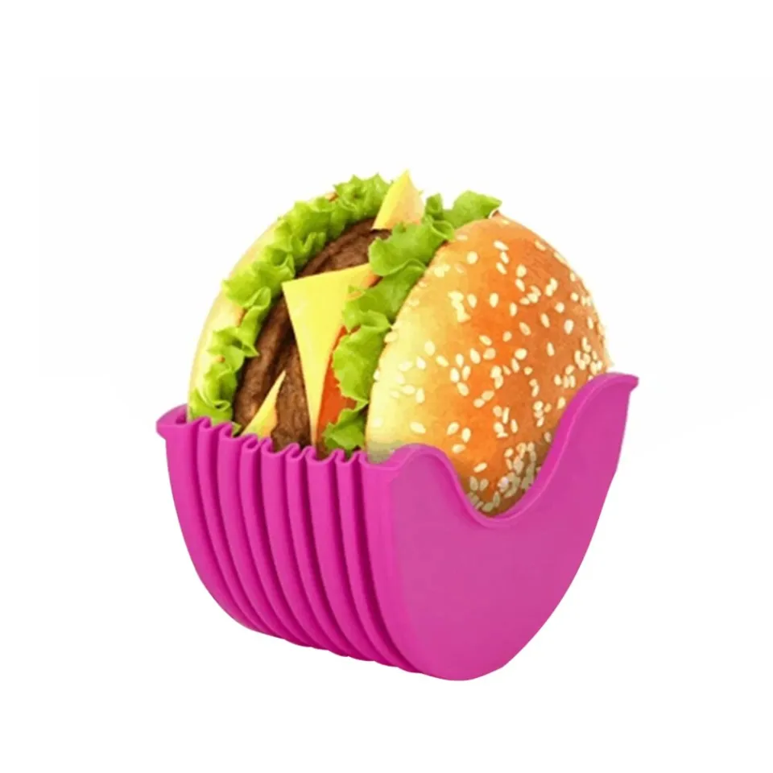
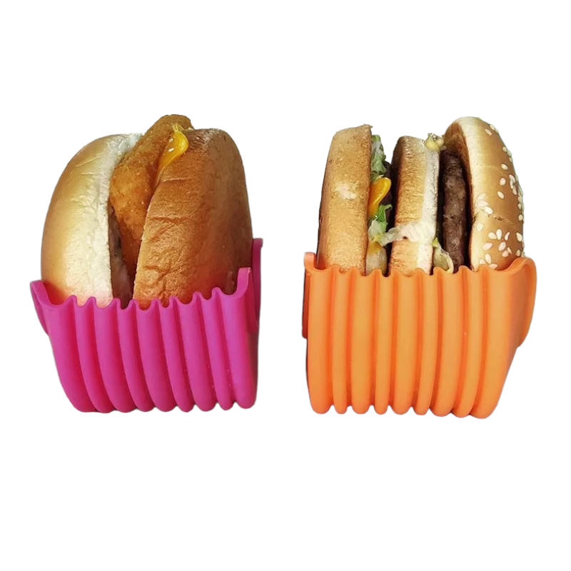
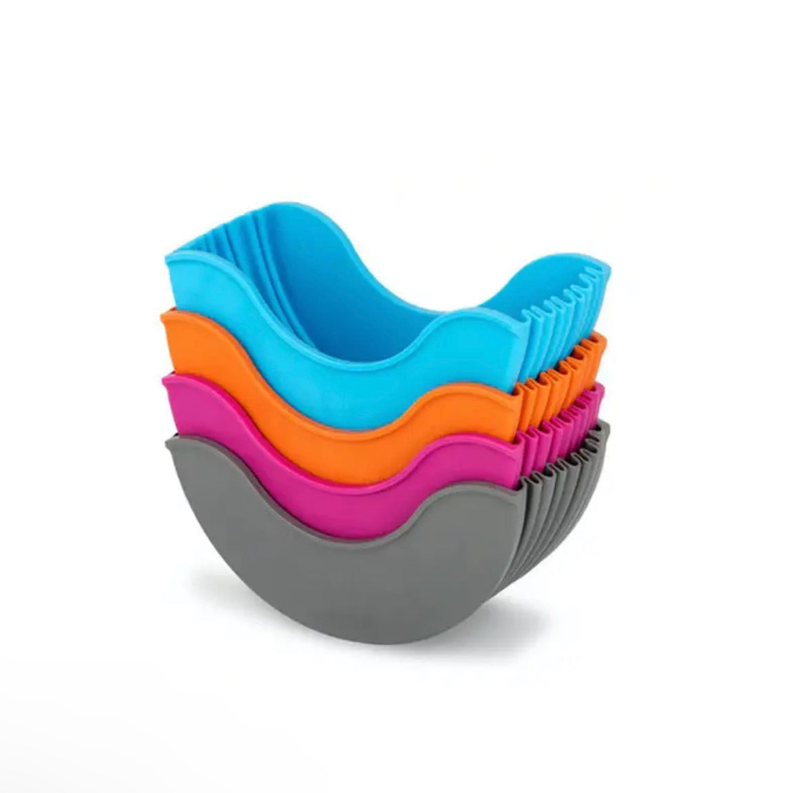
  - BURGER HOLDER

Description:

Ever ordered a burger that looked incredible, then immediately regretted how hard it was to actually eat? Stacked high, sauce dripping, fillings escaping from every side. Whether it is a loaded gourmet burger or a simple takeaway classic, keeping it together can feel like a juggling act. This reusable, expandable burger holder is designed to gently support your burger from first bite to last. It hugs the sides to help hold everything in place while the base catches excess juices, keeping things contained and less messy. You can rest your burger in it between bites without it tipping over, sliding apart, or falling flat. It is practical for everyday use at the table, on the couch, at your desk, or in the car. For some people it simply makes burgers easier to manage. For others, it reduces strain, improves grip, and allows for more controlled bites without needing to cut everything up first. Made from flexible food grade silicone, it is durable, reusable, dishwasher safe, and designed to stack neatly when not in use.

Great for:
🍔 Keeping tall or loaded burgers intact
🖐️ Reduced grip strength or hand fatigue
🦾 One handed eating or limited arm movement
🧠 Tremors or coordination challenges
👩‍🦽 Supporting easier assisted feeding
🧼 Anyone who prefers cleaner hands while eating
🚗 Eating in the car or on the go
🌿 Reducing single use paper and foil

Features:
🩵 Expandable depth from 3.8cm up to 8cm
🥤 Base catches excess juices
♻️ Reusable and eco friendly
🧽 Dishwasher safe and easy to clean
🔥 Heat resistant and non stick
💪 Flexible, durable silicone that resists tearing
📦 Stackable for compact storage
Details:
Material: Plastic (BPA Free)
Size: 10cm (W) x 5.6cm (H) x 3.8cm — 7.9cm (D)
Weight: 80 grams
Package Contains: 1x Burger Holder
Age Guidance: Suitable for ages 5 years and up. Supervision recommended for younger children.

How to Use:
🍔 Place your burger into the holder from the top
🤲 Gently squeeze or adjust the sides to fit your burger
🪑 Rest it on a table, lap, or tray between bites
😋 Enjoy more controlled bites with less mess
🧼 Wash in hot soapy water or place in the dishwasher after use

Care Instructions:
🧽 Dishwasher safe
🌡️ Heat resistant
🚫 Do not use over direct flame

