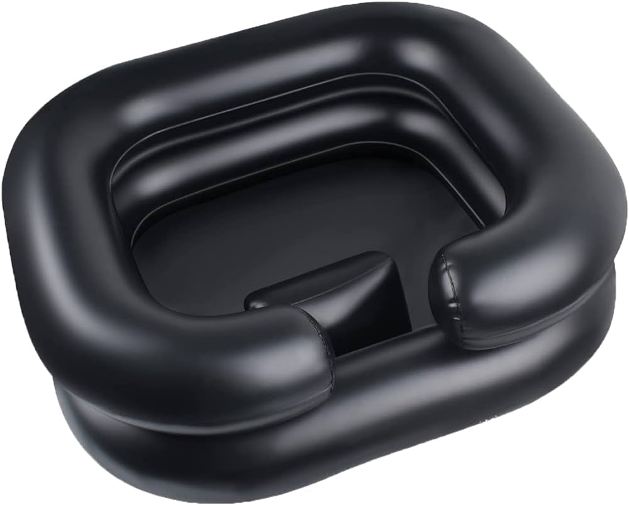
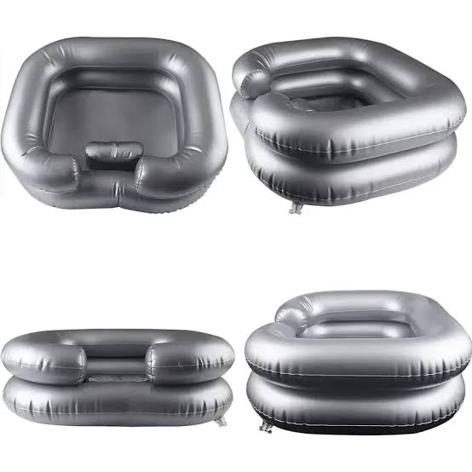
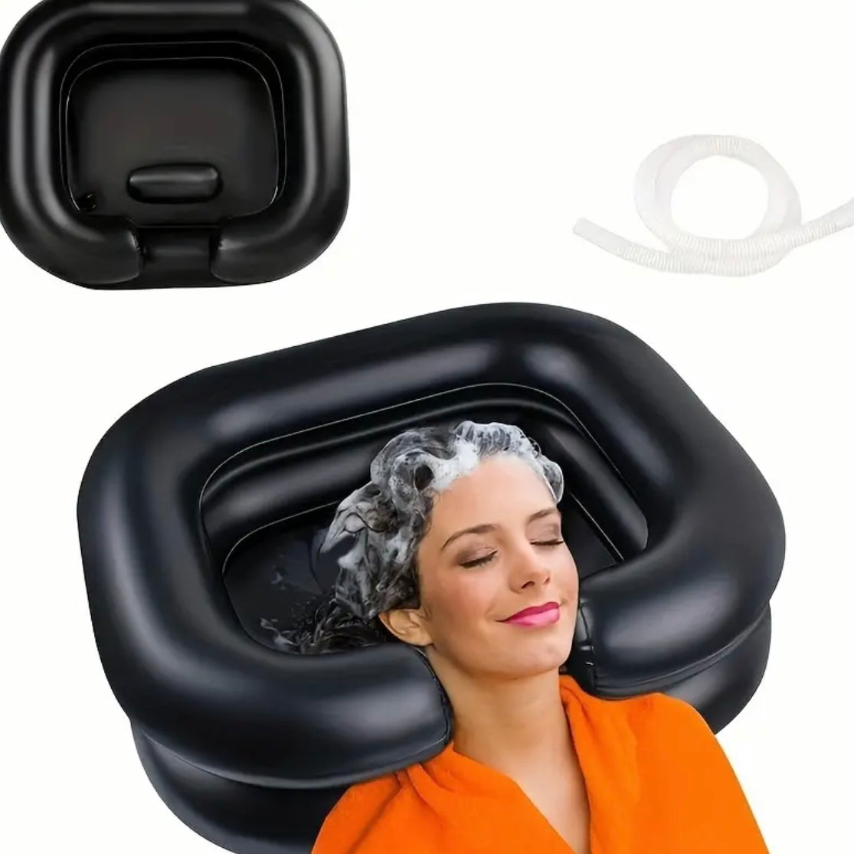
  - INFLATABLE SHAMPOO BASIN

Description:
Feeling clean can change your whole day, especially when you’re really unwell.
An inflatable shampoo basin like this makes it possible to wash hair while lying back in bed or reclining comfortably, so you can still get that fresh hair feeling even when you’re not able to sit up for a shower or be up and about. For many people, that small reset can make a huge difference to comfort, confidence, and how you feel in yourself.
This style of hair washing basin is designed for supported hair washing, so it’s ideal for use with a caregiver, whānau member, or support worker. The soft double-layer design helps support the head and neck, and the drain hose helps guide water away for easier clean-up. A practical option for home care, hospital stays, recovery periods, and long-term health needs.

Great for:
🛏 Washing hair while lying back in bed
🛋 Washing hair while reclining on a couch or day bed
🪑 Supported hair washing while resting in a reclined position
🫶 Supported hair washing with a caregiver, whānau, or support worker
💤 Low-energy days and fatigue-friendly routines
🌿 Managing chronic pain and flare-up days
🧠 Dizziness, POTS, and balance support
🧩 ME/CFS (Chronic Fatigue Syndrome) and post-exertional malaise (PEM)
🫁 Long COVID and post-viral recovery support
🧬 Ehlers-Danlos Syndrome (EDS), hypermobility, and joint instability
🧷 CCI (craniocervical instability) support when lying down with neck support
🔥 CRPS and pain conditions where movement is difficult
🦾 Muscular dystrophy and muscle weakness support
🧠 Motor neurone disease and progressive condition support
🦴 Post-op recovery and injury recovery
🏥 Hospital stays and recovery at home
🏠 Making personal care easier and more accessible at home
Features:
🛁 Inflatable shampoo basin for hair washing
🖤 Raised sides to help contain water
🧠 Double-layer design for head and neck support
🚿 Drain hose included for easier clean-up
🪣 Helps guide water into a bucket or container
🪶 Lightweight and portable
🧳 Easy to deflate and store between uses
🧼 Suitable for home care and supported routines
👐 Designed for supported use when needed

Details:
Material: PVC
Size: Please see sizing below…
Outer Measurements: 57.5cm (L) x 47cm (W) x 20cm (H)
Inner Measurements: 38cm (L) x 27cm (W) x 20cm (H)
Neck Rest: 11cm - 13cm (L) x 8.5cm (W) Approx.
Weight: 400g (Un-inflated)
Package Contains: 1x Shampoo Basin
Age Guidance: Suitable for teens and adults. Children should use with adult assistance and supervision. Not a toy.

How to Use:
🫧 Inflate the basin until firm and supportive
🛏 Position the basin under the head and neck while lying back or reclining
🪣 Place the drain hose into a bucket or suitable container
🚿 Use warm water and shampoo to wash hair gently
🧽 Drain water as needed, then wipe and dry the basin after use
🧳 Deflate and store once fully dry

Care Instructions:
🧼 Wipe clean with warm soapy water after use
💧 Rinse and drain fully
🌬 Allow to air dry completely before storing
🚫 Avoid harsh cleaners and sharp objects near the PVC
🔍 Check for wear or damage before use

