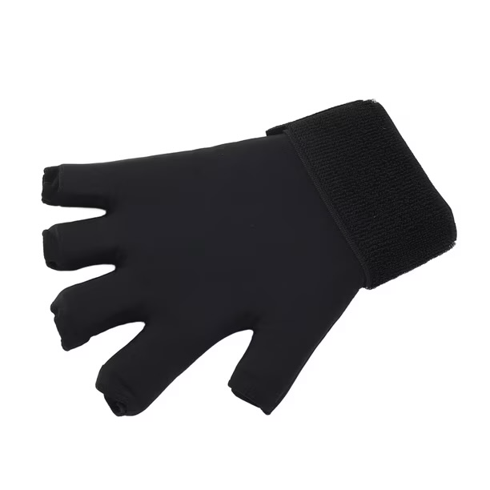
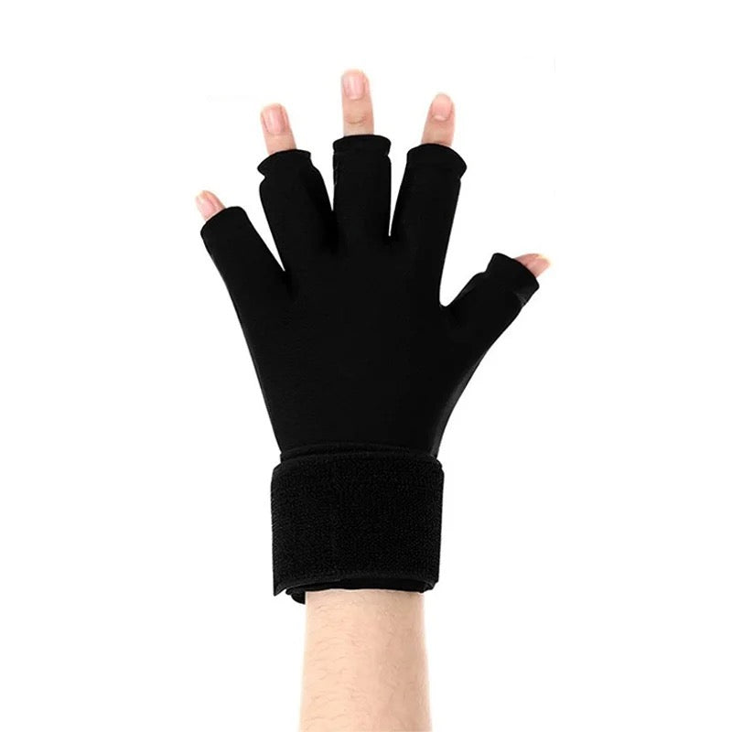
  - REUSABLE ICE PACK – FULL HAND

Description:
Hand pain, stiffness, swelling, or injury can make everyday movement feel uncomfortable and frustrating, especially when you are trying to rest, recover, or simply get through the day.
This hot and cold compression glove is designed to provide targeted temperature support to the hand, fingers, thumb, and wrist. The gel-lined glove can be used either warmed or cooled to help support comfort and ease in the affected area, while the soft flexible design allows it to wrap around the hand for more even coverage.
The adjustable strap helps keep the glove in place, and the design is suitable for use on either hand. It can be used at home during rest, recovery, or downtime as part of a personal comfort routine.

Great for:
🖐️ Hand, wrist, thumb, and finger discomfort
🧊 Cold therapy for swelling or inflammation
🔥 Warm therapy for stiffness or tight muscles
🧠 Carpal tunnel and repetitive strain support
🦴 Arthritis and joint discomfort or pain management
💪 Strains, sprains, and minor injury recovery
🫶 Everyday hand comfort and rest
🏡 Use at home during downtime or recovery

Features:
🧊 Hot and cold gel compression support
🖐️ Full hand glove-style coverage
☝️ Fingerless design keeps fingertips free
🔄 Suitable for left or right hand
🪢 Adjustable wrist strap for a secure fit
♻️ Reusable gel design
🧤 Soft flexible outer material for comfort
Details:
Material: Neoprene, Gel Ice Packs
Size: One size fits most (left and right hand)
Weight: 520 grams
Package Contains: 1x Hand Ice Pack Support
Age Guidance: Sized for teen and adults. Younger users with supervision. Not a toy.

How To Use:
For Cold Therapy:
🧊 Place the glove flat in the freezer for at least 2 hours before use.
🖐️ Remove from the freezer and check the temperature before placing it on your hand.
🪢 Slide your hand into the glove and adjust the wrist strap until comfortably secure. Do not overtighten.
⏱️ Use for up to 20 minutes at a time, then remove and allow your skin to return to its normal temperature before using again.

For Heat Therapy:
🔥 Make sure the gel is evenly distributed throughout the glove before heating.
♨️ Place the glove flat in the microwave and heat for 20 seconds initially.
🌡️ Carefully check the temperature and for any hot spots before use. If more warmth is needed, heat for a further 10 seconds at a time, checking after each interval.
🖐️ Once comfortably warm, slide your hand into the glove and adjust the wrist strap without overtightening.
⏱️ Use for up to 20 minutes at a time.

Care Instructions:
🧼 Wipe clean with a damp cloth
🌬️ Air dry fully before storing
🚫 Do not machine wash or tumble dry
📦 Store in a clean, dry place
Notes/Caution:
🌡️ Always check the temperature before placing the glove against your skin, particularly after heating.
⏱️ Use hot or cold therapy in short intervals and allow your skin to return to its normal temperature between uses.
🖐️ Stop use if you experience burning, excessive numbness, skin discolouration, or increased discomfort.
⚠️ Take extra care if you have reduced sensation, circulation difficulties, or difficulty recognising temperature changes.
🚫 Do not use on broken, damaged, or irritated skin.
🚫 Do not use if the glove or gel compartments are damaged or leaking.

