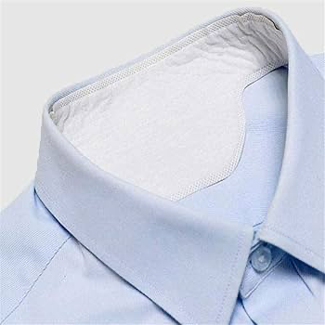
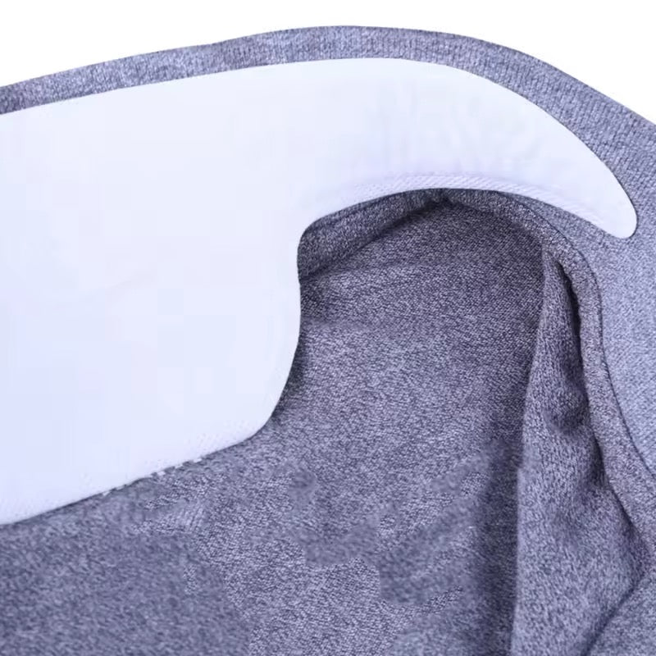
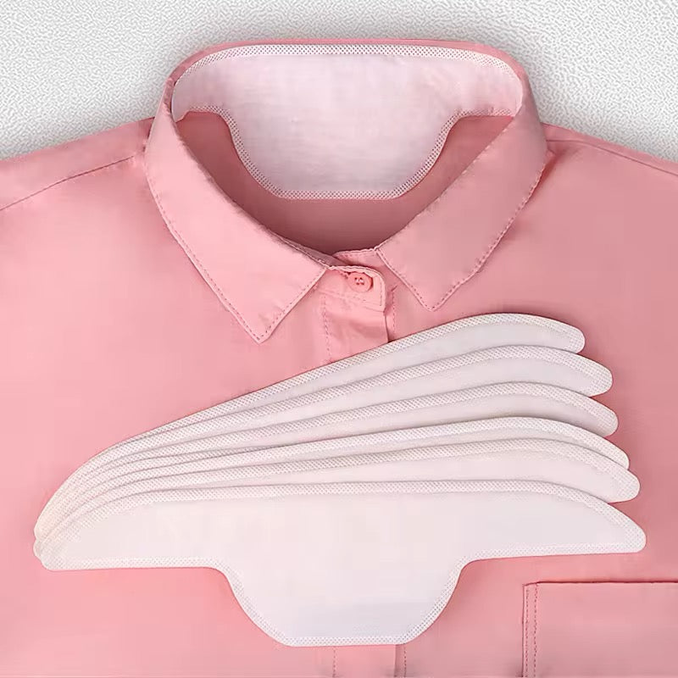
  - DISPOSABLE SHIRT COLLAR LINER SWEAT PAD

Description:

Ever get to the end of the day and notice your collar did not quite make it?

These disposable shirt collar liners quietly take the pressure off, helping your shirts stay fresher and more comfortable from morning through to night.

They sit inside the collar and catch moisture and skin contact before it reaches the fabric. That means fewer marks, less discolouring, and shirts that look better for longer, even on warm days or busy shifts.
They are a simple, no fuss way to get more wear out of your clothes and feel a bit more comfortable while you do it.
Great for:
👔 Work shirts, uniforms, and school shirts
🧑‍💼 Long days at the office
🏥 Shift work, healthcare, teachers, and front of house staff
🌡 Warm weather and busy days
💦 People who sweat more or run warm
🧍 Sitting, moving, and working all day
🧳 Travel and overnight stays
🧼 Reducing washing and fabric wear
📅 Events, meetings, and special occasions
🌱 Making clothes last longer

Features:
🩹 Discreet and hidden inside your collar
🧵 Soft non woven fabric
💧 Absorbs moisture and skin contact
📌 Adhesive backing to keep it in place
🪶 Lightweight and comfortable
🗑 Disposable for easy clean up
Details:
Material: Non-woven fabric
Size: 27cm (L) x 7.5cm (H) x 0.1cm (D)
Weight: Less than 10 grams
Package contains: Choses number of liners
Ages: Recommended age: 12+ (or younger with adult help/supervision).

How to Use:
👕 Make sure the inside of your collar is clean and dry
📌 Peel off the backing
👔 Stick the liner along the inside of your shirt collar
👕 Wear as normal while it absorbs moisture
🗑 Remove and dispose of at the end of the day
Care Instructions:
🗑 These liners are single use
🚫 Do not wash or reuse

