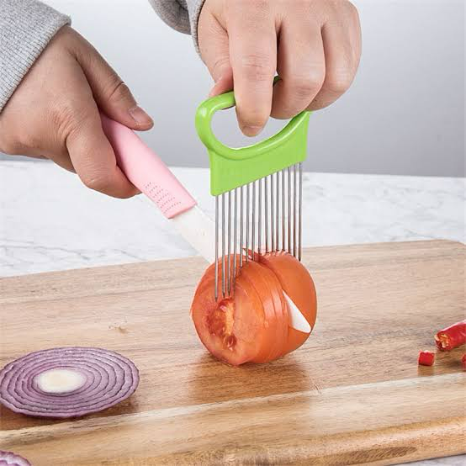
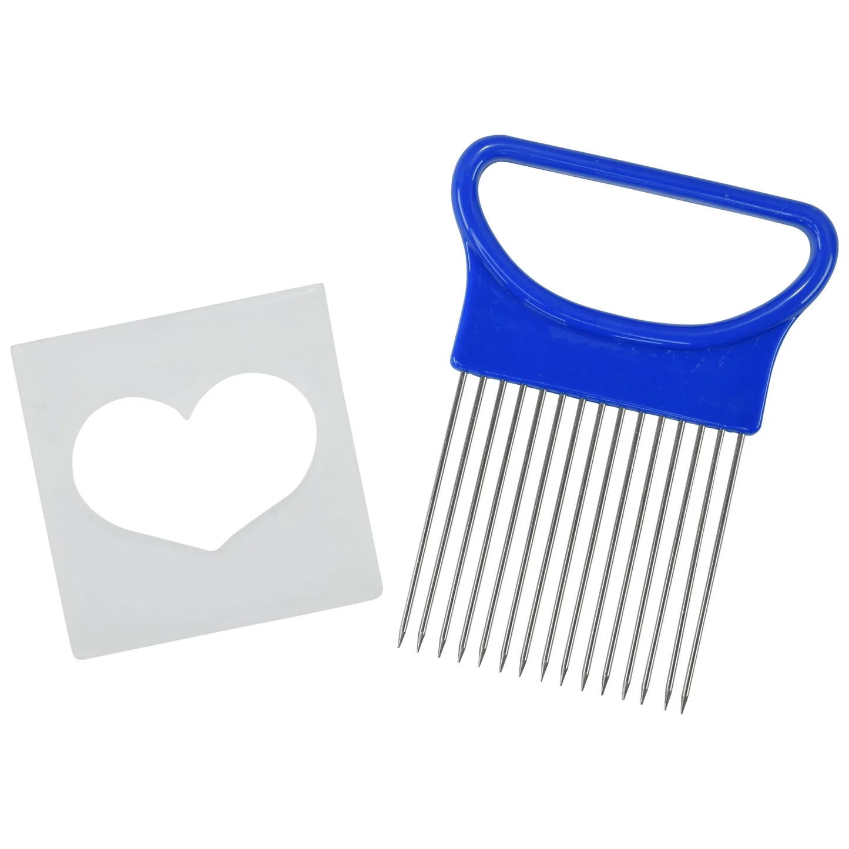
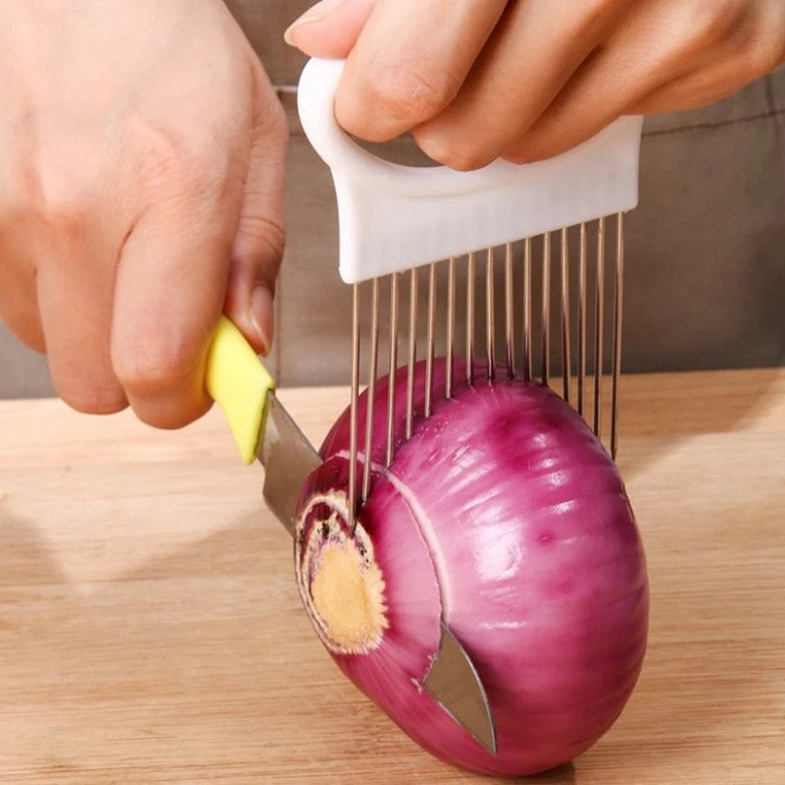
  - VEGETABLE SLICING AID INSTRUCTIONS

Description:

Good tools make cooking feel smoother, safer, and more enjoyable for everyone. This vegetable chopping aid is designed to support steadier slicing, improved control, and more predictable results in the kitchen across a wide range of ages, bodies, and abilities.
By holding food securely in place, it helps reduce slipping, rolling, and sudden movement while cutting. The evenly spaced prongs act as both a visual and physical guide, making it easier to create uniform slices without rushing or over-gripping. This can support ongoing independence in the kitchen, whether you’re building skills, adapting after injury, or navigating changing strength, coordination, or sensation over time.
It’s well suited to everyday cooking, learning safe knife skills, maintaining confidence as needs change, or simply making tricky foods easier to slice on any given day.

Great for:
🥕 Kids learning safe knife skills
👵 Older adults wanting extra stability and confidence
♿ People with disabilities supporting everyday independence
🧠 Cerebral Palsy, Ehlers-Danlos syndrome, Parkinson’s disease, tremors, and neurological conditions
🦽 Spinal cord injury, hand or arm injury, or reduced hand function
🖐 Limited grip strength, coordination challenges, or fatigue
🧑‍🍳 Anyone who finds slicing uneven, slippery, or difficult at times
🍽 Everyday meal prep and batch cooking

Works well with:
🍅 Tomatoes
🥒 Cucumbers
🥔 Potatoes and kumara
🥕 Carrots
🫑 Capsicums
🍎 Apples and pears
🍋 Lemons and citrus
🍌 Bananas
🥩 Soft meats and other produce
If the prongs can be inserted into the food, it can help stabilise it and guide slicing.

Features:
🔪 Stainless steel prongs to hold food securely during cutting
📏 Even spacing to guide consistent slice sizes
🧩 Functions as both a stabiliser and slicing guide
🖐 Reduces the need to grip food directly
🧼 Dishwasher safe for easy cleaning
♻️ Reusable and designed for long-term use
🎨 Available in orange, green, and white on request
🛡 Includes a protective plastic sheath for safe storage

Details:
Material: stainless steel and quality plastic
Size: 11cm (L) x 8cm (W)
Weight: 27 grams
Package includes: 1x vegetable chopping aid + plastic sheath to keep the sharp ends contained.
Age Guidance: 12+ years. Younger children require adult supervision. Not recommended for very young children due to sharp prongs. Not a toy.

How to use:
🥕 Insert the prongs into the food you want to cut
✂️ Slice between the prongs or use the aid to hold food steady
🧩 Remove once cutting is complete
🧼 Clean and store safely using the sheath

Cleaning:
🧼 Hand wash or dishwasher safe
🌬 Dry thoroughly before storing
🛡 Always store with the protective sheath in place

