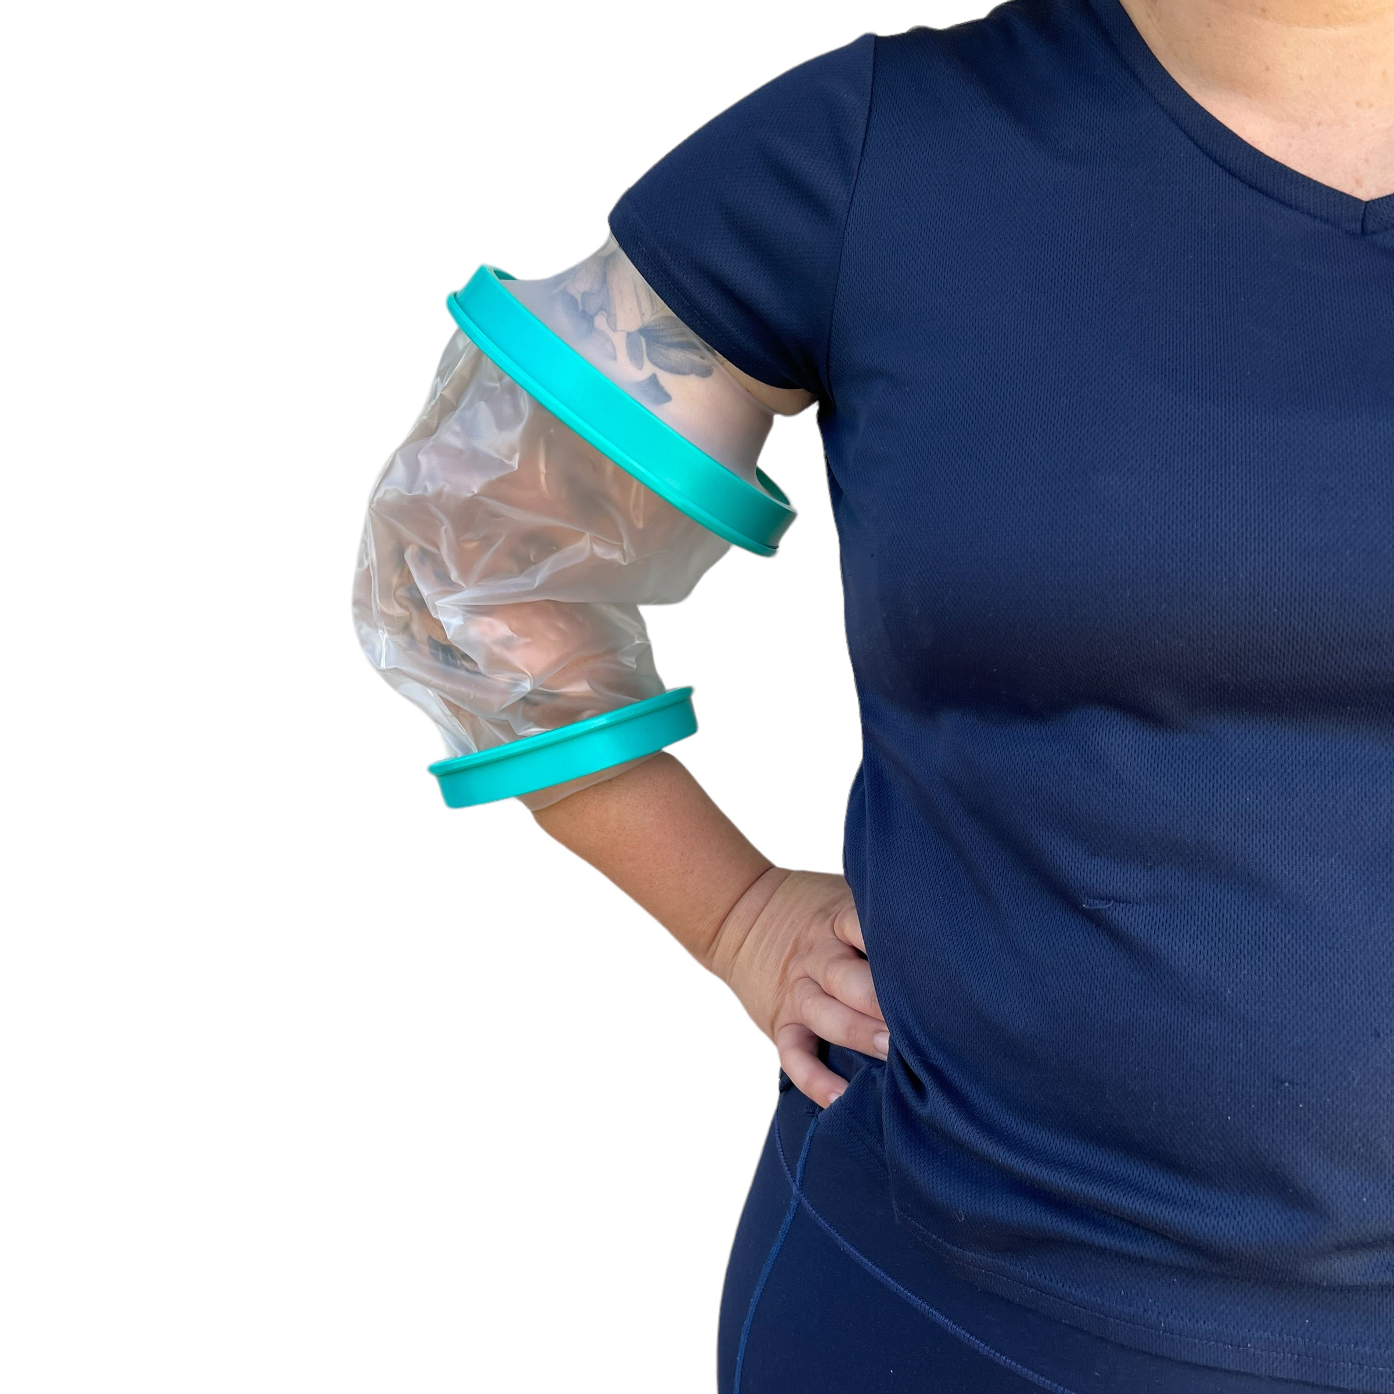
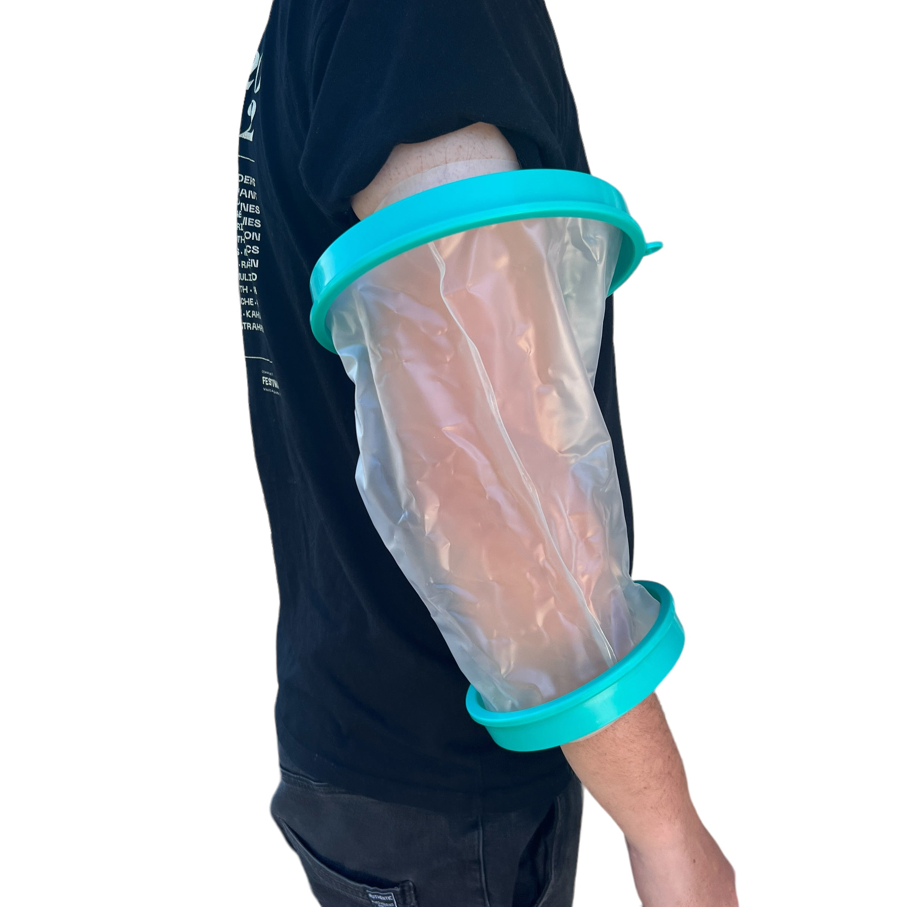
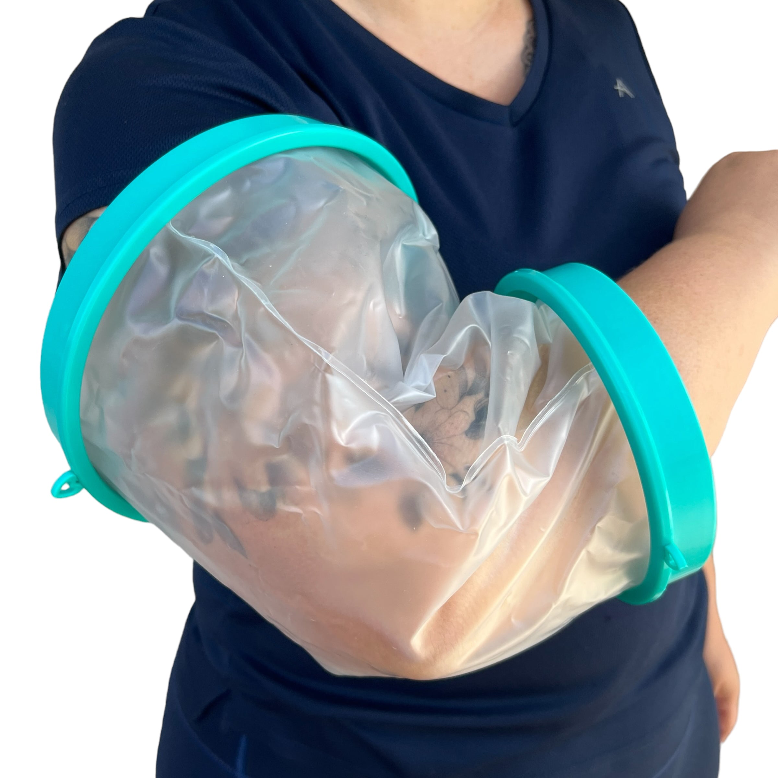
  - WATERPROOF SHOWER COVER (ARM)

Description:
Showering with a PICC line, wound dressing, or healing site can quickly become stressful when you are trying to keep everything dry at the same time. This waterproof upper arm dry sleeve helps create a protective barrier around your arm so you can shower, bathe, wash hair, or get on with everyday life with a little less worry about water reaching the area. Designed with a waterproof seal and flexible sleeve design, it helps keep PICC lines, dressings, bandages, and healing areas more protected from splashes and water exposure during everyday routines. The soft flexible material stretches to fit a range of upper arm sizes while remaining lightweight and comfortable to wear.
Helpful for showers, bathing children, rainy days, beach trips, around pools, recovery periods, and everyday situations where you want an extra layer of protection around your PICC site or dressing.

Great for:
🚿 Showering and bathing with a PICC line or dressing
🩹 Helping keep healing sites and bandages dry
🧼 Washing hair more easily
👶 Bathing children while protecting your arm
🌧️ Rainy days and outdoor appointments
🏖️ Beach trips and sandy environments
🏊 Around pools or splash zones
🏥 Recovery periods and wound care routines
🫶 Everyday protection from splashes, dirt, and tugging
⚡ Making shower routines feel less stressful

Features:
💧 Waterproof upper arm protection sleeve
🫶 Designed for PICC lines, dressings, and wound protection
🪶 Lightweight and flexible design
🌿 Latex free materials
Details:
Material: PP, Silicone, PVC Plastic
Size: See below for sizes…
Small: 15.5cm (W) x 32cm (L)
Large: 15.5cm - 21cm (W) x 35cm (L)
Weight: 65 grams
Package Includes: 1x PICC Line Waterproof Cover
Age Guidance: Suitable for teens and adults. Younger users may require assistance with fitting and removal depending on arm size and support needs.

How to Use:
💧 Stretch the seal gently over your hand and arm
🩹 Position the sleeve so the dressing or PICC site is fully covered
🫶 Ensure the seals sit directly against dry skin for best protection
🌬️ Gently release trapped air if needed to improve the seal
🚿 Remove carefully after showering or bathing

Care Instructions:
🧼 Rinse with clean water after use
🌬️ Allow to dry fully before storing
📦 Store flat in a cool, dry place
☀️ Avoid prolonged direct sunlight or heat exposure

Please Note:
⏱️ Recommended for shorter showering and bathing periods, generally around 20 minutes or less
💧 Not designed for full water immersion or swimming
🌡️ Warm showers may cause condensation or sweating inside the sleeve
🔍 Always check seals are sitting correctly before exposing to water
⚠️ This product does not replace medical advice or clinical care instructions

